**Special Moves Program**

**General**

This document explains how to make special moves by focusing on the programming part.

# **1 – Special Moves Scripts**

The function of these scripts is to be able to program special movements easily.

## Scr_A01_InitiateObject

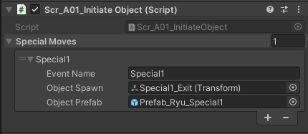

This script works to start prefabs with animation events. It is placed on the player's child object, Animator.

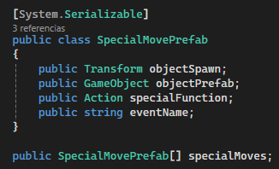

It works with the public class SpecialMovePrefab, which creates an array, each slot asking for three requirements.

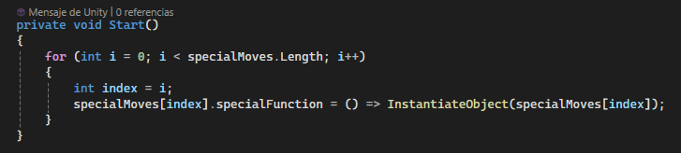

For each Special Move, a function and an event are generated. The name is determined by the string eventName.

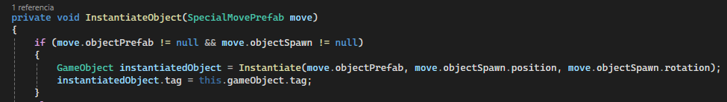

The InstantiateObject function is responsible for generating the prefab in the corresponding position and with the corresponding tag.

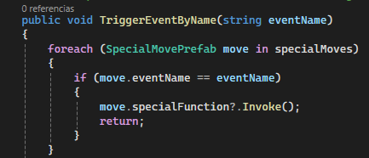  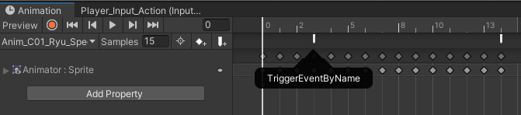 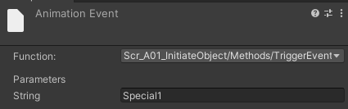

The TriggerEventByName function It is the event that we select in the Animation window, within this event we write the attack that we want to execute.

## Scr_A02_DestroyObject

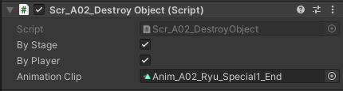

This script destroys an object after colliding with another.

# **2 – Projectile**

1- Carpeta

2- Sprtie y Animator

3- Prefab

4- Rigidbody

5- Script Initiate + Script Destroy + Script Move

6- Add exit location, Add animation Event and code

## 1. Components

Is the main object of the object, it contains all the children and essential components for the character.

### 1.1 - Transform

Determines the position, rotation, and scale of the object.

